**Task4**

Develop the queries to retrieve information from the OLAP operations performed and to gain a deeper understanding of the sales data through different dimensions, aggregations, and filters.

**Project: OLAP Operations (using Redshift or PostgreSQL)**

Objective: Perform OLAP operations (Drill Down, Rollup, Cube, Slice, and Dice) on the "sales_sample" table to analyze sales data. The project will include the following tasks:

**1. Database Creation**

Create a database to store the sales data (Redshift or PostgreSQL). Create a table named "sales_sample" with the specified columns: Product_Id (Integer)

Region (varchar(50))-like East ,West etc Date (Date)

Sales_Amount (int/numeric)

**Query:**

CREATE DATABASE sales_data;

CREATE TABLE sales_sample (

Product_Id INT,

Region VARCHAR(50),

Date DATE,

Sales_Amount NUMERIC

);

**Output:**

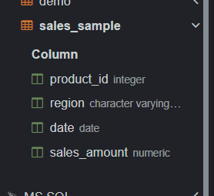

**2. Data Creation**

Insert 10 sample records into the "sales_sample" table, representing sales data.

**Query:**

INSERT INTO sales_sample (Product_Id, Region, Date, Sales_Amount) VALUES

(1, 'East', '2024-01-01', 1000),

(2, 'West', '2024-01-02', 1500),

(1, 'East', '2024-01-03', 1100),

(2, 'West', '2024-01-04', 1400),

(3, 'North', '2024-01-05', 1200),

(4, 'South', '2024-01-06', 1300),

(3, 'North', '2024-01-07', 1250),

(4, 'South', '2024-01-08', 1350),

(1, 'East', '2024-01-09', 1050),

(2, 'West', '2024-01-10', 1550);

**Output:**

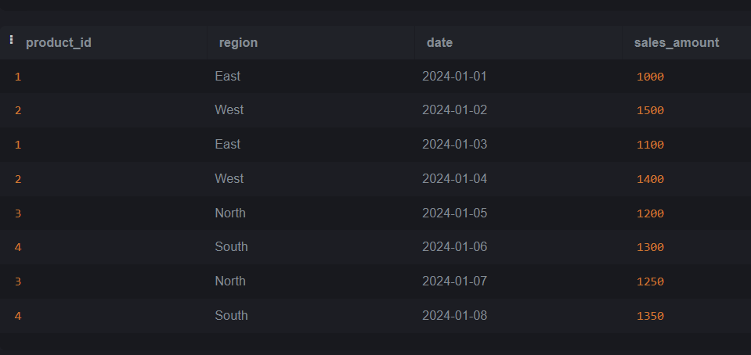

**3. Perform OLAP operations**

a) Drill Down-Analyze sales data at a more detailed level. Write a query to perform drill down from region to product level to understand sales performance.

**Query:**

SELECT Region, Product_Id, SUM(Sales_Amount) AS Total_Sales

FROM sales_sample

GROUP BY Region, Product_Id

ORDER BY Region, Product_Id;

**Output:**

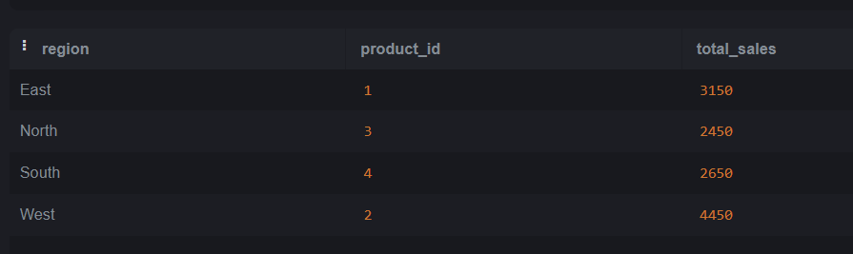

b) Rollup- To summarize sales data at different levels of granularity. Write a query to perform roll up from product to region level to view total sales by region.

**Query:**

SELECT

Region,

Product_Id,

SUM(Sales_Amount) AS Total_Sales

FROM

sales_sample

GROUP BY

ROLLUP (Region, Product_Id)

ORDER BY

Region, Product_Id;

**Output:**

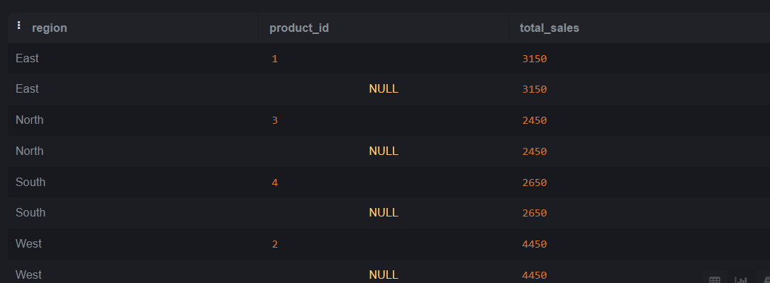

c) Cube - To analyze sales data from multiple dimensions simultaneously. Write a query to Explore sales data from different perspectives, such as product, region, and date.

**Query:**

SELECT

Product_Id,

Region,

Date,

SUM(Sales_Amount) AS Total_Sales

FROM

sales_sample

GROUP BY

CUBE (Product_Id, Region, Date)

ORDER BY

Product_Id, Region, Date;

Output:

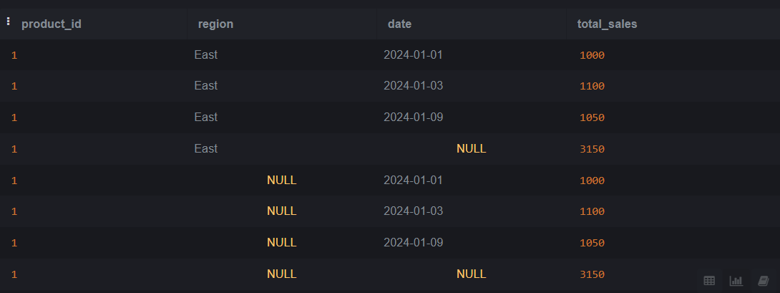

d) Slice- To extract a subset of data based on specific criteria. Write a query to slice the data to view sales for a particular region or date range.

**Query to View Sales for a Particular Region (e.g., 'East'):**

SELECT

Product_Id,

Region,

Date,

Sales_Amount

FROM

sales_sample

WHERE

Region = 'East'

ORDER BY

Date, Product_Id;

Output:

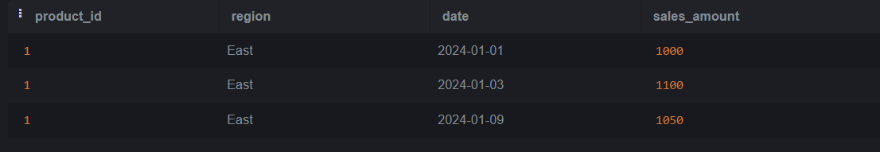

**Query to View Sales Within a Specific Date Range (e.g., '2024-01-01' to '2024-01-10'):**

SELECT

Product_Id,

Region,

Date,

Sales_Amount

FROM

sales_sample

WHERE

Date BETWEEN '2024-01-01' AND '2024-01-10'

ORDER BY

Date, Product_Id;

**Output:**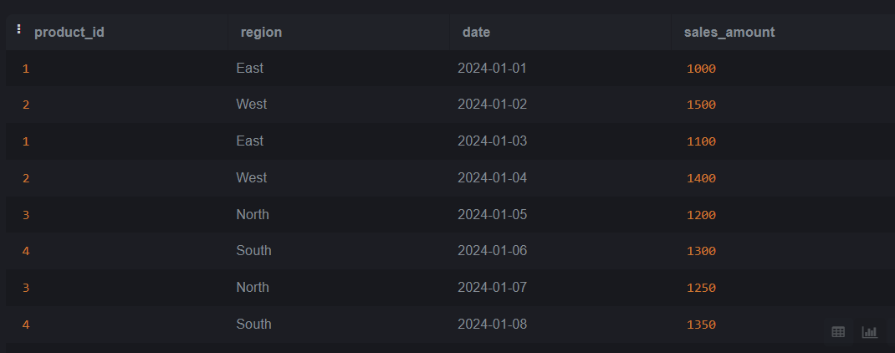

e) Dice - To extract data based on multiple criteria. Write a query to view sales for specific combinations of product, region, and date

**Query:**

SELECT

Product_Id,

Region,

Date,

Sales_Amount

FROM

sales_sample

WHERE

(Product_Id = 1 AND Region = 'East' AND Date = '2024-01-01') OR

(Product_Id = 2 AND Region = 'West' AND Date = '2024-01-02') OR

(Product_Id = 3 AND Region = 'North' AND Date = '2024-01-05')

ORDER BY

Product_Id, Region, Date;

**Output:**

